Patel's Analog and Digital Measurement Co. Pvt. Ltd,
A/6 Functional Electronic Estate, Bhosari Indl. Area, Pune- 411026.
Tele: (020) 27120290/ 27120324, Fax: (020) 27122043
E-mail: padmco@vsnl.net , Arleen@dataone.in
_________________________________________________________________________________________________
Inquiry Form-Bench Type Taping machine for Diamond Shaped Coil
Please provide the requested information:
If engineering drawings are available, please send these with your enquiry.

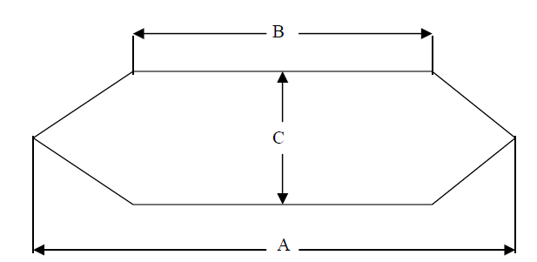
Specifications of coil to be taped
Length of straight portion to be taped (B) | Maximum (mm) |  | Minimum (mm)
Distance between coil sides | A (mm) | B (mm) |  | C (mm)
Coil Section | Maximum (mm) |  | Minimum (mm)
Tape Spool | OD (mm) | ID (mm) |  | Width (mm)

Please fill your following information
Company name :
Company website, :
Company E-mail ID :
Company Contact No.

